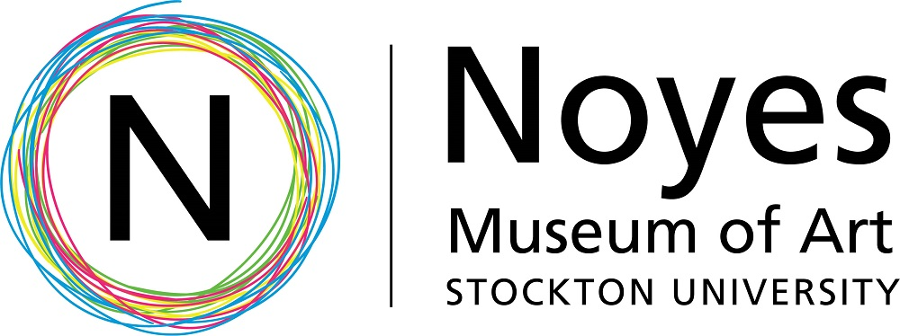

Education Guide October 4 – January 6, 2019

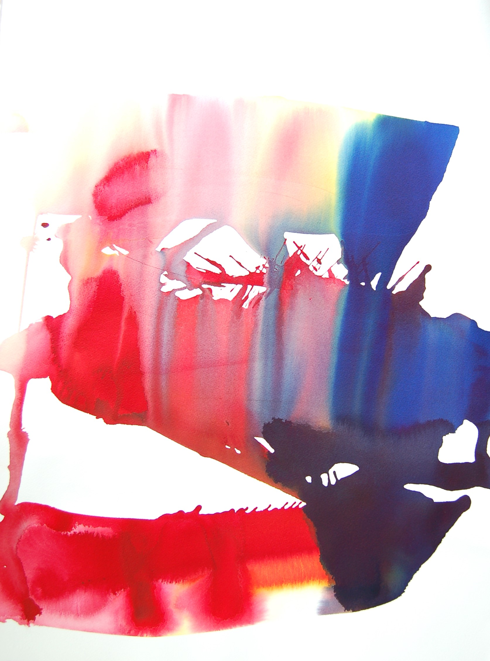
Chromatic Payoff
David French

Chromatic Payoff is a solo exhibition of oil paintings by David French. Using a limited palette with pure color on canvas, he creates an immediate visual experience for the viewer. He has developed a process of applying paint that acts as a signifier of identity and cultural concerns.

French, who was diagnosed with cancer in 2000, was profoundly shaped as an artist and individual by the experience. He is now cancer-free but this event informs his artwork to this day. Rather than representing the moments he had, he creates in order to make sense of things that occurred or that he had wished to occur. In the face of personal oblivion, he hopes to locate himself through his art.

David French, Untitled, oil on canvas

He chooses to work with oil paint on stretched linen or acrylics and inks on paper primarily because of their fluid, fleshy, visceral and organic quality, not unlike the body. The painting surface is similar to skin; the illusory depth a body in space. Over three decades of producing non-objective painting, he has worked to create a bridge between gestural abstraction and process painting. Relational and non-relational painting experimentation has enabled him to nuance a language between mechanical automation and personal expression.

To French, the essential painters’ toolbox consists of the flat surface, and red, yellow, blue and white. He thinks of his interaction with these basic materials as a collaborator and sculptor. He equates physical action to those tool box components - everything contributes proportionally. The paint provides optical structure; he provides human agency. The palette is skipped in these works, in an effort to work more directly with the essential materials. Working in a manner where he does not represent something, he touches on the very essences of painting.

French believes he only has a tool box, a given set of materials, certain abilities, knowledge and his burning desire to make something with imperfect hands. He searches for the best way forward in beautiful and fluid foreign surroundings. Things occurred, are still occurring, and have yet to occur. He thinks of his work in relation to this phenomenon. We can only perceive a small slice of what is happening around us. French’s work appears to have been frozen in time, coming from somewhere, maybe just out of the picture plane and about to move forward past that moment. The work draws strength from its juxtaposition. French hopes that the experience of viewing his artwork will revolve around this particular sense of heightened awareness.
David French, Untitled, oil

For more information on David French visit:
www.davidfrenchfineart.com
Funding for the Noyes Museum of Art is provided in part by the NJ State Council on the Arts/Department of State, a partner agency of the National Endowment for the Arts, and the Geraldine R. Dodge Foundation.

The Noyes Arts Garage of Stockton University:
www.artsgarageac.com 609.626.3805
The Noyes Museum of Art of Stockton University:
www.noyesmuseum.org 609.626.3420
Check us out on Facebook, Twitter, Instagram and YouTube

