

Education Guide

***Education Trailblazers***

*Education Trailblazers* was created by Charles Barbin and Randi Meekins, local artists who own and operate Dunes Gallery in Brigantine, New Jersey, in partnership with the Noyes Museum of Art of Stockton University, the artists, Create48 and the Atlantic City Arts Foundation.

The mural celebrates Stockton’s 50th anniversary and features Juanita High, founding director of the N.J. Equal Opportunity Fund and a member of the Stockton University Foundation Board of Directors; Dorothie W. Dorrington, educator and former Atlantic City Board of Education president; Vera King Farris, former Stockton president, and Hannah Pierce Lowe, former principal of Indiana Avenue Vocational School (for colored girls) in Atlantic City. *Education Trailblazers* is one of two murals finished in time for the NAACP National Convention during July 2022, which is taking place in the city for the first time since 1968.

Randi Meekins, one of two artists of the mural expressed the following: “To be able to honor not one, but four women, who paved the way for people that look like me makes me very proud. Two of the educators actually taught my grandparents when they were in school, so I really feel connected to this project in many ways.” A biography of each woman honored in the mural is written below.

This mural is located at the corner of Martin Luther King Jr. Boulevard and Atlantic Avenue in Atlantic City, New Jersey.

**Biographies of Women Honored in *Education Trailblazer*:**

**Dr. Vera King Farris, Ph.D. (1938-2009):**

Above: Photograph of   
Dr. Vera King Farris

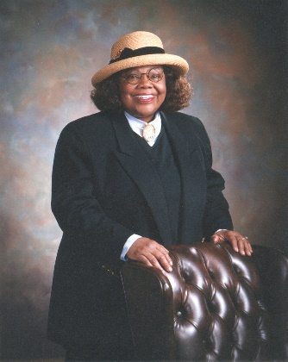

Dr. Vera King Farris was born and raised in Atlantic City and was third in her AC High School graduation class of 1954. A graduate of Tuskegee Institute (biology degree in 1959), Farris earned her master’s and doctoral degrees in zoology from the University of Massachusetts, Amherst.

Dr. Farris was the first African American female President of a New Jersey State College and one of the first in the nation. She served Stockton with distinction and vision for 20 years as president, from 1983 until her retirement in 2003. She arrived at Stockton from Kean University, where she was Vice President for Academic Affairs.

Under her outstanding leadership, Stockton experienced dramatic growth, became a nationally ranked institution, and increased its SAT scores, minority enrollment, and retention. She also established one of the nation's first Holocaust Resource Centers and the first master’s program in Holocaust and Genocide Studies. During her tenure the College constructed ten buildings, including the Sports Center, West Quad Health Sciences Building, one of the world’s largest geothermal heating and cooling systems, and the Michael Graves designed Arts and Sciences Building.

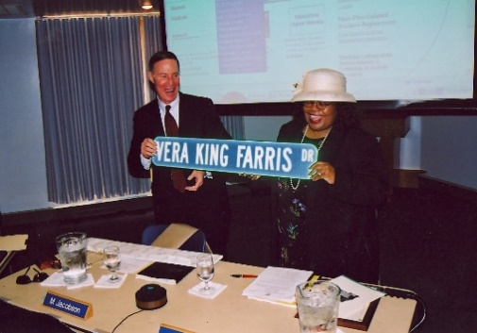

Above: Photograph of Dr. Vera King Farris

Farris also focused on hiring outstanding faculty dedicated to students and scholarship, expanded degree programs, and led the development of Stockton’s highly regarded Student Affairs Division.

Dr. Farris believed in serving as a role model to minority and disadvantaged students. Growing up poor in Atlantic City, she said that “she understood early on that she was smart and that education could give her a better life.” She was a fierce advocate for keeping a Stockton education affordable through innovative fundraising initiatives and having students graduate.

Her academic background in the sciences led her to become an international leader in environmental awareness through the development of Stockton’s geothermal heating and cooling system and as host to the summer Governor’s School on the Environment for high school students.

Dr. Farris was also the first African-American woman selected for the Board of Directors of Flagstar Companies, owner of Denny's Restaurants, and she was instrumental in the development and implementation of their anti-discrimination policies.

**Dr. Juanita High, Ph.D. (1934-Present):**

Born and raised in Atlantic City, Dr. Juanita High is a highly-regarded educator and administrator. She holds a B.A. degree from Montclair State, an M.A. degree from University of Pennsylvania, and a doctorate degree from Rutgers University, New Brunswick.

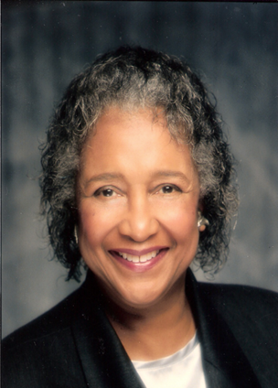

Above: Photograph of   
Dr. Juanita High

Dr. High began here academic career as an elementary school teacher and would later teach English at Atlantic City High. She often cited that “her teachers and her family, many of whom were teachers, were her role models”.

She is regarded for her leadership as the founding Director of the New Jersey Educational Opportunity Fund, authoring guidelines for the statewide program, which became a model for similar programs across the country. This led to her accepting the position as the first full-time Affirmative Action Director at Stockton College and later the Executive Assistant to Dr. Vera King Farris, president of Stockton University.

Among her many leadership roles, she established the Atlantic City Tomorrow Leadership Program, she is president of the Bright’s Villa Board of St. James AME Church, which provides housing for 141 families in Atlantic City, and is currently an active member of the Stockton Foundation Board of Directors, and a charter member of the Theta Kappa Omega Chapter of Alpha Kappa Alpha Sorority, Inc.

As someone who is dedicated to assisting student achieve their academic goals, Dr. High She established a Distinguished Student Book Award at Stockton to benefit full-time students in good academic standing with a minimum cumulative GPA of 3.0.

**Dorothie W. Dorrington, ED. S (1927-2005):**

Dorothie Dorrington overcome a learning disability to earn her BS and MS degrees from Glassboro State College (Rowan University) and an ED.S from Rowan.

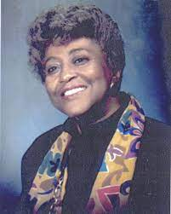

Above: Photograph of   
Dorothie W. Dorrington

A long-term resident of Atlantic City, during her 50-year career, she served in various teaching capacities. Dr. Dorrington was elected to the Atlantic City Board of Education for nine years, five years of which she was president. She consulted with students with disabilities on behalf of Stockton College and wrote and published a book, *Handbook for Classroom Teachers of Reading*.

A community leader and activist, Dr. Dorrington founded 101 Women Plus and the Phi Delta Kappa Iota Chapter Debutante Cotillion of Atlantic City. She was involved in many other community programs providing scholarships to financially challenged students, including the World Links Exchange Program, which set up student exchanges between Atlantic City and Barbados.

Dr. Dorrington was married to Art Dorrington, a national sports pioneer and the first African American professional hockey player. The Dorringtons also formed the Art Dorrington Ice Hockey Foundation 1998 to teach life skills for youth through hockey.

There is a marker on northwest corner of MLK Blvd and Marmora Ave, memorializing Dr. Dorrington’s significant contributions to Atlantic City.

**Hannah Pierce Lowe (1875-1963):**Hannah Pierce Lowe was born in Atlantic City and was a graduate of Rutgers University. She retired as principal of Indiana Avenue Vocational School in Atlantic City (for Colored Girls) from the 1920’s to the 1940’s. She was the founder of the first YWCA in Atlantic City.

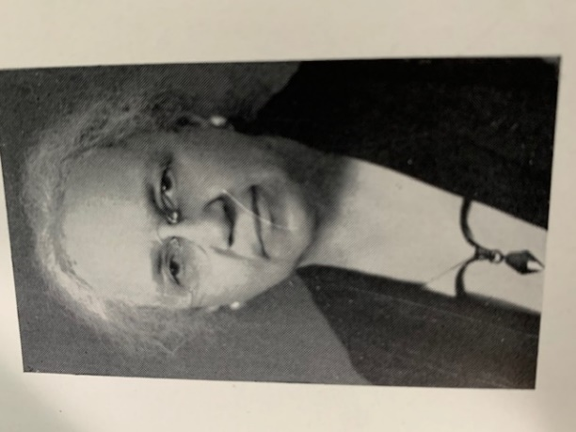

Above: Photograph of   
Hannah Pierce Lowe

Pierce She was the first woman awarded a certificate by the American Teachers Association, in recognition of her professional services as a teacher and administrator (of negroes). She is also a direct descendant of the Gould family of Gouldtown, NJ. Her father, Rev. Jeremiah H. Pierce, was instrumental in organizing the establishment of the St. James A.M.E. Church of Atlantic City circa 1875. Ms. Lowe is credited with documenting the history of the church.

She passed away at age 88 and her obituary was published in the July 18, 1963 edition of Jet Magazine. Her daughter, Ramona Lowe, was the founder of the Market Street Gallery in Harlem, the first African American-owned art gallery and bookstore in New York. She was also a personal associate of noted artist and Atlantic City native, Jacob Lawrence, and famed writer and poet, Langston Hughes. For many years, Ramona Lowe also acted as the personal secretary to Dr. W.E.B. DuBois, the civil rights leader and founder of the Niagara Movement and the NAACP.

Hannah Pierce Lowe’s personal collection and papers were donated to the African American Heritage Museum of Southern New Jersey and are part its permanent collection.

**For more information on Charles Barbin and Randi Meekins, please visit the following:**   
**Website:** [**www.dunesartgallery.com**](http://www.dunesartgallery.com) **Instagram:** **@dunesgallery**

**Thank you to our partners Create48 & the Atlantic City Arts Foundation! For more information on our partners, please visit the following:**

**Create48 · Follow Create48 on Instagram: @create48ac  
Atlantic City Arts Foundation ·** [**www.atlanticcityartsfoundation.org**](http://www.atlanticcityartsfoundation.org) **· staff@atlanticcityartsfoundation.org**

**The Noyes Museum of Art of Stockton University ·** [**http://www.noyesmuseum.org**](http://www.noyesmuseum.org) **· (609) 626-3420   
The Noyes Arts Garage of Stockton University ·** [**www.artsgarageac.com**](http://www.artsgarageac.com/)  **· (609) 626-3805  
Check us out on Facebook, Twitter, Instagram and YouTube.**